**OXSTAR CONSULTANCY ACTIVITY ACTION PHOTOS AND DESCRIPTIONS**

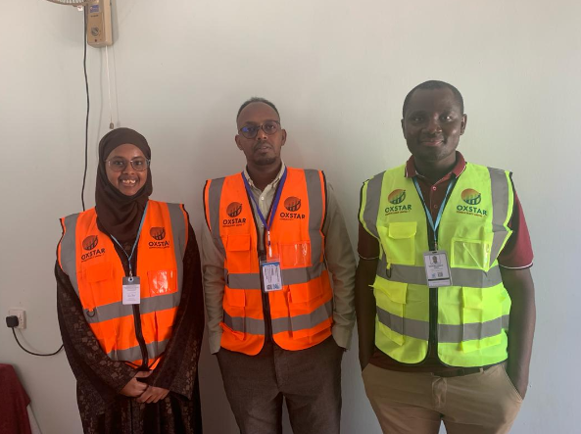

**Website Background/Cover Photo**

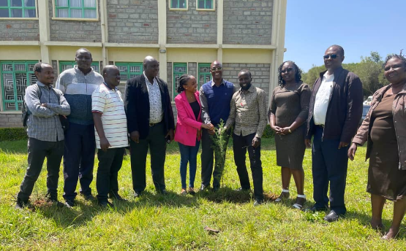

**A photo showing Oxstar Program team participating in Tree Planting Initiative at Moi University in Eldoret City, Kenya.**

The Oxstar program team actively participated in a collaborative tree-planting initiative held at Moi University in Eldoret City, Kenya. During the event, the team joined students and faculty members to plant native saplings across the campus as part of a broader environmental conservation effort. This activity served as a hands-on commitment to combating climate change and enhancing the local ecosystem's biodiversity. The team discussed the long-term benefits of reforestation with university representatives, highlighting the importance of sustainable land management.

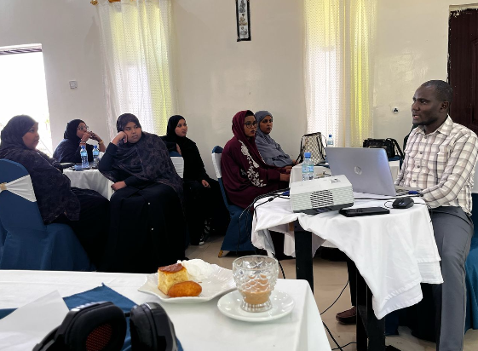

**A photo showing Oxstar team conducting training for field data collection team in Hargeisa, Somaliland for a Baseline survey for the project titled “Women's empowerment for improved nutrition of infants, young children, and mothers in Maroodi-jeex and Togdheer regions in Somaliland.**

The Oxstar team conducted a specialized training session in Hargeisa for a field data collection team tasked with a critical baseline survey. This training focused on a project dedicated to empowering women to improve the nutrition of infants, young children, and mothers across the Maroodi-jeex and Togdheer regions. Facilitators provided technical guidance on specific nutritional indicators and the ethical considerations required when interviewing vulnerable households. The enumerators practiced using mobile data collection tools to ensure the accurate capture of anthropometric measurements and dietary diversity scores.

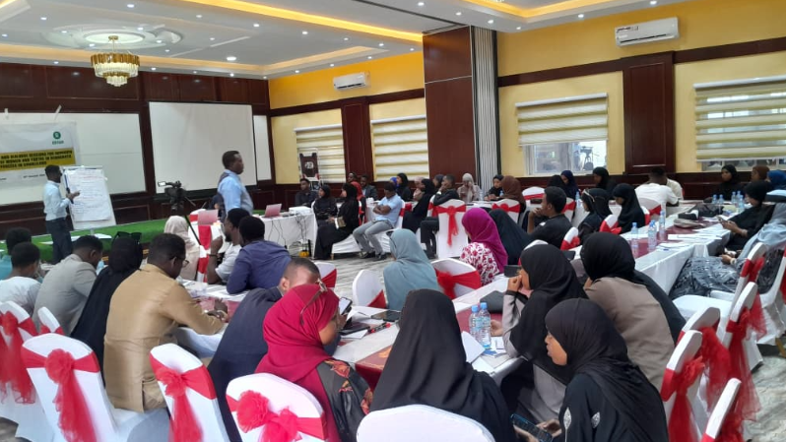

**A photo showing Oxstar program team conducting a workshop on youth engagement in democratic processes in Hargeisa, Somaliland**

The Oxstar program team organized an impactful workshop in Hargeisa focused on enhancing youth engagement in democratic processes across Somaliland. During the sessions, facilitators educated young participants on their fundamental civic rights and the various mechanisms for political participation. The team led interactive group exercises that encouraged the youth to develop strategies for advocating on issues relevant to their communities. Attendees analyzed the barriers to political inclusion and discussed ways to foster more transparent and accountable governance.

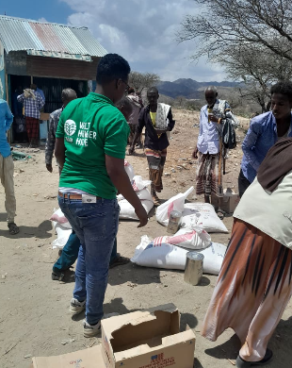

**A photo showing Oxstar team conducting Third Party Monitoring to verify food distribution initiatives implemented by Welt Hunger Hilfe (WHH) and funded by World Food Program in Borama District, Somaliland.**

The Oxstar team conducted a rigorous Third-Party Monitoring (TPM) mission in Borama District to verify food distribution initiatives implemented by Welt Hunger Hilfe (WHH). Funded by the World Food Program, this oversight activity ensured that the delivery of life-saving resources reached the intended beneficiaries efficiently. Supervisors meticulously cross-checked distribution lists and interviewed local recipients to confirm the quantity and quality of the food items received. The team also assessed the safety and accessibility of the distribution points to ensure they complied with international humanitarian standards. By documenting these field realities, Oxstar provided the critical evidence needed to validate the transparency and accountability of the aid operation.

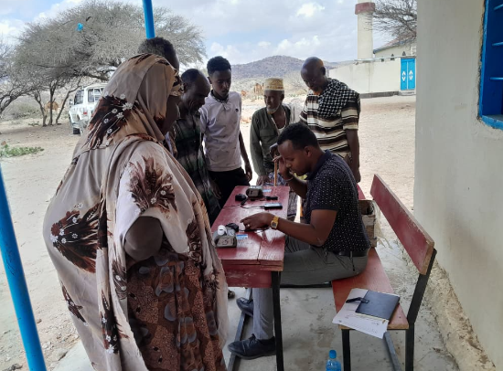

**A photo showing Oxstar team conducting Third Party Monitoring to verification of digital registration of program beneficiaries for food distribution initiatives implemented by Welt Hunger Hilfe (WHH) and funded by World Food Program in Borama District, Somaliland.**

The Oxstar team conducted a specialized Third-Party Monitoring mission in Borama District to verify the digital registration of beneficiaries for food distribution initiatives. This process involved a meticulous audit of the biometric and digital databases managed by Welt Hunger Hilfe (WHH) to ensure data integrity and accuracy. Supervisors performed real-time spot checks at registration centers to confirm that the enrollment protocols funded by the World Food Program were strictly followed. By interviewing registered households, the team successfully cross-referenced physical identities with the digital records to prevent duplication or exclusion errors. This verification exercise provided essential assurance that the digital systems effectively targeted the most vulnerable populations in the region.

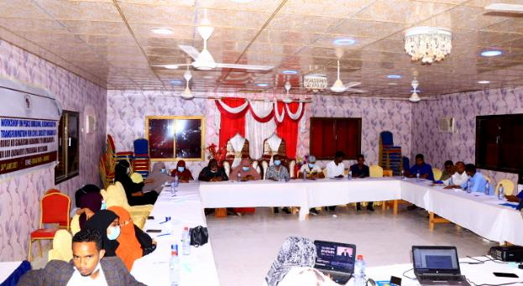

**A photo showing Oxstar Consultancy team conducting Youths for Peace and Reconciliation Training in Garowe City, Puntland State of Somalia.**

The Oxstar Consultancy team facilitated a dynamic "Youths for Peace and Reconciliation" training program in Garowe City to empower young leaders in Puntland. Throughout the sessions, the team provided participants with essential conflict resolution skills and techniques for fostering social cohesion within their communities. The facilitators led intensive workshops where youth leaders analyzed local drivers of instability and developed collaborative peacebuilding strategies. By engaging in role-playing exercises, the attendees practiced mediation methods designed to bridge divides and promote restorative justice. The program successfully established a dedicated network of young ambassadors committed to promoting a culture of non-violence and long-term reconciliation across the region.

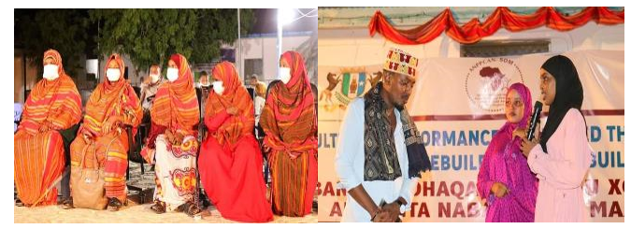

**A photo showing Oxstar Consultancy team supporting the *cultural art performance for Peacebuilding in Puntland, Somalia****.*

A message during the culture performance event was centered towards encouraging more dialogue between members of the cultural sectors and representatives of the community in the areas of peace-building and conflict prevention. The activity brought together key government officials, partners and three famous drama teams in Puntland, performing all forms of Somali traditional culture songs and dances. This event resulted to clear understanding of participants discovering and understanding that cultural drama, poetry and peace songs contributes positively to peace and harmony, hence enabling a better environment in which society can have a sense of belonging.

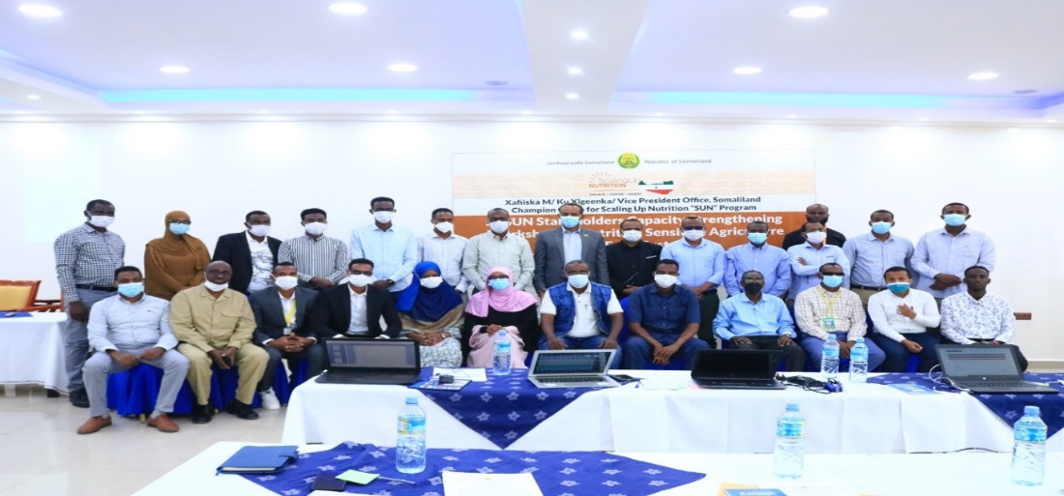

# A photo showing Oxstar team supporting Advocacy Meeting with CSOs and Academia in Promoting the Contribution of Nutrition Sensitive Sectors in Somaliland.

The deliberations from the consultative meeting were consolidated in a common position paper, which included inputs from 38 international and local organizations, 6 academic entities, the media, and other stakeholders. The common position paper was intended for the Government, Development Partners and other relevant stakeholders to effectively address the immediate and underlying causes of the under nutrition by accelerating actions to scale up nutrition specific and nutrition interventions across Somaliland through an integrated multi-sectoral response.

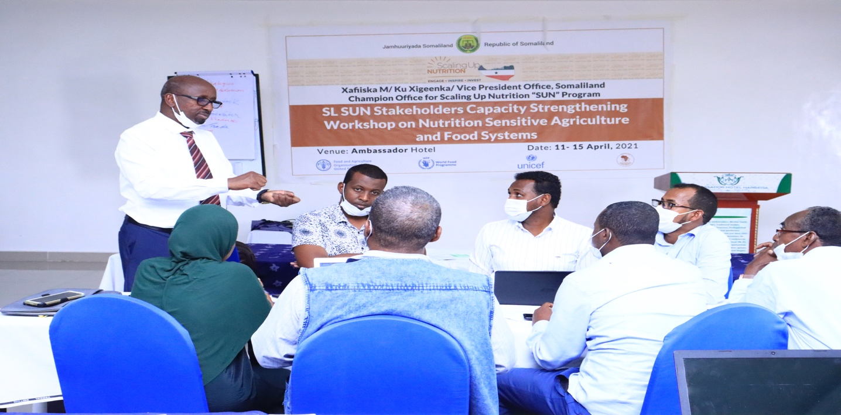

**A photo showing Oxstar Program team conducting Somaliland Scaling Up Nutrition (SUN) Stakeholders Capacity Strengthening Workshop on Nutrition Sensitive Agriculture and Food Systems**

The overall aim of the workshop was to create a synergy and platforms of addressing the acute malnutrition and micronutrients deficiency syndrome in women and children below five years of age. During the meeting, Oxstar Lead Consultant Mr. Samuel Otieno gave a detailed presentation on food fortification. Some of the key thematic food fortification areas presented by Mr. Otieno included importance of food fortification on addressing critical micronutrients deficiencies in Somaliland such as Vitamin A, Iron and Folate, challenges of implementing food fortification interventions and Multi-Sectoral food fortification recommendations.

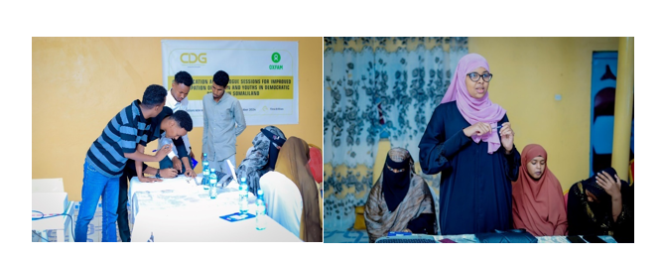**A photo showing Oxstar Program team facilitating a Group Discussion Sessions during Civic Education and Importance of Citizen Participation in the Electoral Process in Somaliland**

The participants discussed the political rights granted by the Somaliland Constitution, beginning with the right to vote. They examined how voting is not only a fundamental right but also a critical responsibility in ensuring that leaders are elected through a fair and democratic process. Participants reflected on the significance of informed voting, where citizens make decisions based on the needs of the community and the policies of candidates, rather than external pressures or biases.

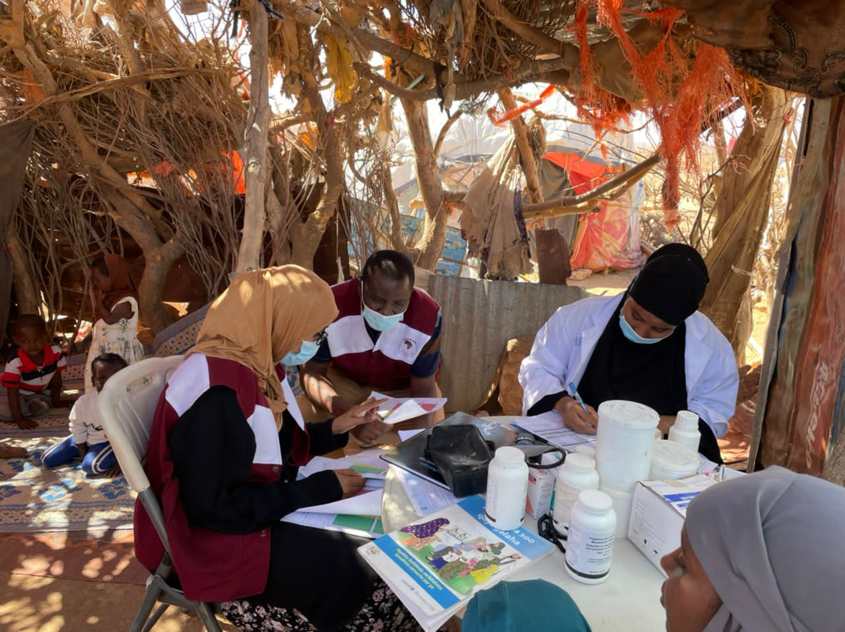

**Oxstar team conducting spot-check monitoring and supervision on Mobile Health facilities in Sool region, Somaliland**

The Oxstar team conducted a comprehensive spot-check monitoring and supervision mission focused on mobile health facilities throughout the Sool region of Somaliland. These critical assessments were designed to evaluate the operational efficiency and service delivery standards of clinics reaching nomadic and remote communities. During the site visits, supervisors meticulously reviewed medical supply chains and verified that healthcare providers were adhering to established clinical protocols. The initiative also provided a valuable opportunity for the team to engage directly with local staff, offering on-site technical support to address immediate logistical challenges. By identifying gaps in real-time, the Oxstar team ensured that the most vulnerable populations continued to receive high-quality, life-saving interventions.

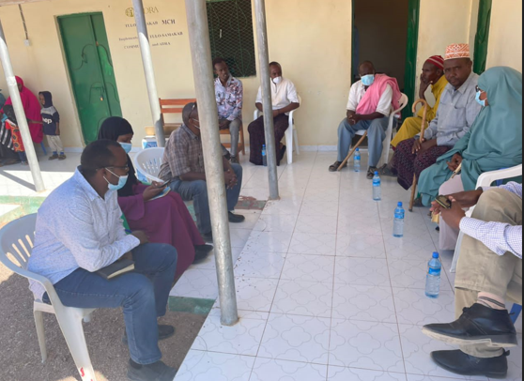

**A photo showing Oxstar program team conducting a Focus Group Discussion with the community Health committee in Hargeisa district, Somaliland.**

The Oxstar program team convened a productive Focus Group Discussion with the local Community Health Committee in the Hargeisa district of Somaliland. During the session, facilitators engaged with committee members to gather qualitative insights regarding the accessibility and effectiveness of regional health services. The team actively listened to the community's primary concerns and documented the specific health challenges faced by residents in the district. Participants shared valuable feedback on existing medical programs, which allowed the team to identify critical areas for future improvement. This collaborative dialogue fostered a stronger partnership between the program staff and the local leadership responsible for public health oversight.

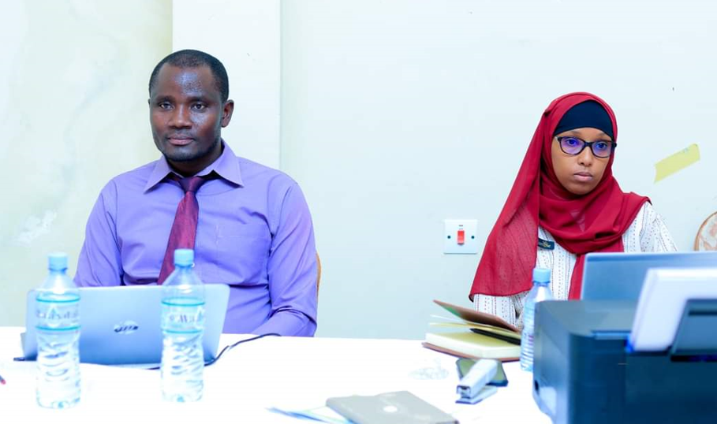

A photo showing Oxstar consultancy program team conducting a validation workshop for **Somaliland Local government Association Strategic Plan for 2023-2027 in Burao District, Somaliland**

The Oxstar consultancy program team hosted a critical validation workshop in Burao District to review the Somaliland Local Government Association (ALGASL) Strategic Plan for 2023–2027. This high-level gathering brought together regional stakeholders and local authorities to finalize the roadmap for decentralized governance over the next five years. During the sessions, the consultancy team presented the core pillars of the plan while soliciting direct feedback from the attendees to ensure local needs were accurately represented. Participants engaged in rigorous discussions to verify that the proposed objectives aligned with the practical realities of municipal administration in Somaliland. The team meticulously documented all recommendations and technical inputs provided by the association members to refine the final document.

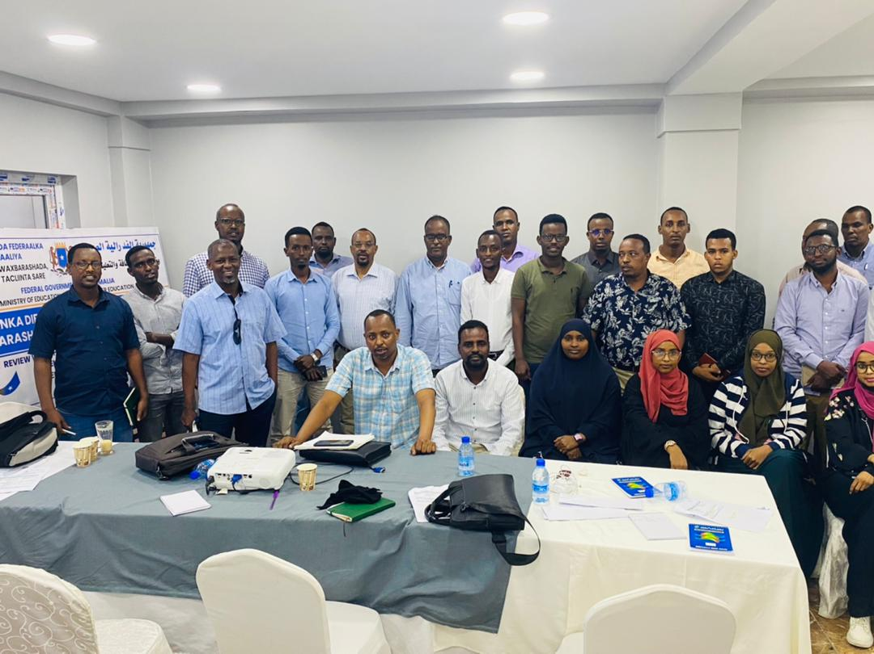

**A photo showing Oxstar consultancy program team facilitating capacity building program for government and civil society organization on monitoring and evaluation skill strengthening in Mogadishu, City Somalia.**

The Oxstar consultancy program team facilitated a comprehensive capacity-building program in Mogadishu aimed at strengthening monitoring and evaluation skills for government and civil society organizations. Throughout the training, the team provided participants with technical expertise on designing robust data collection frameworks and outcome-tracking indicators. The facilitators led interactive sessions that allowed attendees to apply theoretical M&E concepts to their specific organizational projects. Representatives from various sectors collaborated to identify common challenges in measuring program impact and shared best practices for reporting results. The consultancy team also introduced advanced digital tools to streamline the evaluation process and improve the accuracy of field data.

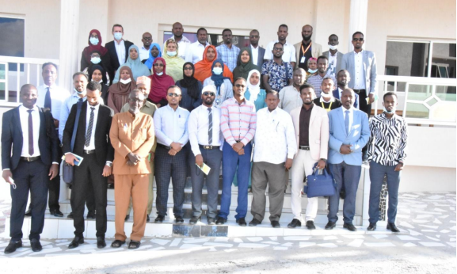

***A Group Photo Showing National Consultation Workshop on Nutrition and Productive Sector Linkages Facilitated by Oxstar Consultancy Limited in Hargeisa, City, Somaliland.***

Oxstar Consultancy Limited successfully facilitated a high-level National Consultation Workshop in Hargeisa to explore the vital linkages between nutrition and the productive sectors. The event brought together experts from agriculture, livestock, and health departments to address the root causes of food insecurity in Somaliland. During the sessions, the Oxstar team guided participants through an analysis of how increased local production could directly improve nutritional outcomes for vulnerable households. Stakeholders engaged in collaborative breakout groups to identify policy gaps and opportunities for cross-sectoral integration. The consultancy team also presented data-driven strategies aimed at aligning economic development goals with public health priorities.

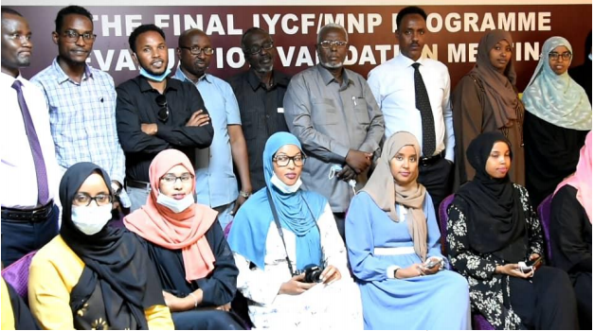

***A Group Photo showing the Final IYCF Programme Endline Evaluation Validation Meeting Facilitated by Oxstar Consultancy Limited in Hargeisa, City, Somaliland.***

Oxstar Consultancy Limited facilitated the final validation meeting in Hargeisa to present the findings of the Infant and Young Child Feeding (IYCF) Programme endline evaluation. The consultancy team shared comprehensive data regarding the impact of the intervention on local breastfeeding practices and complementary feeding habits. During the session, stakeholders reviewed the key performance indicators to verify that the program had achieved its intended nutritional targets. The facilitators led a rigorous discussion where participants analyzed the successes and challenges documented throughout the implementation phase. Members of the health ministry and partner organizations provided their final inputs to ensure the evaluation report accurately reflected the field realities.

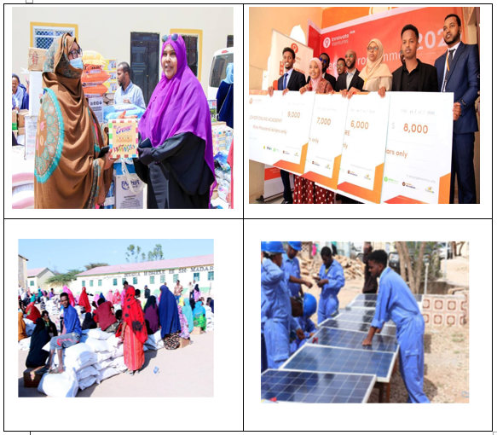

**Photos Showing Summary of food distribution, Solar Energy and SME’s Empowerment Initiatives supported by Oxstar Consultancy Limited in Hargeisa City Somaliland.**

Oxstar Consultancy Limited spearheaded a multi-sectoral relief effort in Hargeisa that integrated food distribution, solar energy solutions, and the empowerment of small and medium-sized enterprises (SMEs). The team coordinated the delivery of essential food baskets to vulnerable households to address immediate nutritional needs within the community. Simultaneously, they oversaw the installation of solar energy systems to provide sustainable and cost-effective power to local businesses and public facilities. The consultancy team also conducted specialized training sessions for SME owners to enhance their financial management and operational resilience. These interconnected initiatives allowed residents to reduce their overhead costs while significantly increasing their economic productivity. By combining humanitarian aid with long-term infrastructure and business support, the project successfully fostered a more self-reliant urban ecosystem.

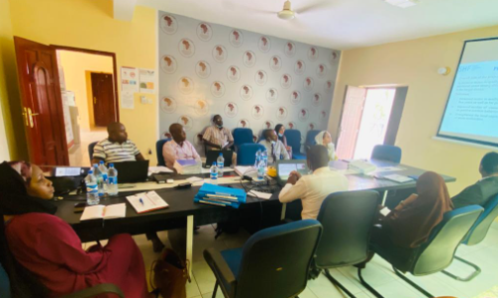

**A photo showing Oxstar Program Team Mr. Samuel Otieno John presenting project achievements and lessons learnt during the UN-OCHA –Somalia Humanitarian Fund (SHF) team spot-check mission in Hargeisa, City Somaliland**

Mr. Samuel Otieno John of the Oxstar program team presented the project’s key achievements and lessons learned during a high-profile spot-check mission in Hargeisa. The presentation was delivered to the UN-OCHA – Somalia Humanitarian Fund (SHF) team as part of their rigorous monitoring and oversight process. During the session, Mr. John highlighted the measurable impact of the humanitarian interventions on the local community while detailing the specific strategies used to overcome operational hurdles. He utilized data-driven evidence to demonstrate how the SHF-funded activities met their intended benchmarks and provided value for money. This exchange allowed for a transparent review of the program's successes and fostered a collaborative environment for future project planning.

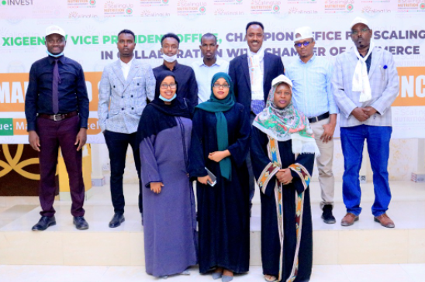

**A photo showing Oxstar Consultancy team participating in the Launching of the Somaliland Scaling-Up Nutrition (SUN) Business Network in Hargeisa Somaliland.**

The Oxstar Consultancy team participated in the official launch of the Somaliland Scaling-Up Nutrition (SUN) Business Network in Hargeisa. During the event, the team engaged with private sector leaders and government officials to discuss market-based solutions for improving national nutrition. The consultants highlighted the critical role of local businesses in fortifying food systems and increasing the availability of affordable, nutrient-dense products. Participants explored collaborative strategies to align commercial interests with public health goals to combat malnutrition across the country. By joining this influential platform, the Oxstar team reinforced its commitment to fostering multisectoral partnerships for sustainable development.

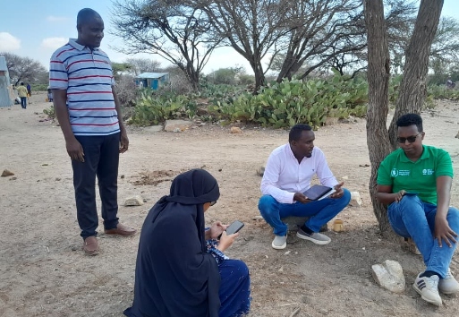

**A photo showing Oxstar program team conducting key interview with the WHHH program manager during field pot-check and verification activity in Borama district, Somaliland.**

The Oxstar program team conducted a critical key informant interview with the WHH program manager during a field spot-check and verification activity in Borama District. This meeting allowed the team to gather detailed insights into the operational management and technical implementation of the ongoing food security initiatives. During the discussion, the team scrutinized program timelines, resource allocation, and the specific challenges faced by the implementing partner on the ground. The interview served as a vital qualitative component of the verification process, complementing the physical data collected from distribution sites.